CS 464 Introduction to Machine Learning

Ekin Uyumaz - Bora Bardük - Duygu Durmuş - Mert İnan - Muhammed Çavuşoğlu

{ekin.uyumaz; bora.barduk; duygu.durmus; mert.inan; m.cavusoglu}@ug.bilkent.edu.tr

Detailed and Concrete Description of Datasets

Chosen art movements:

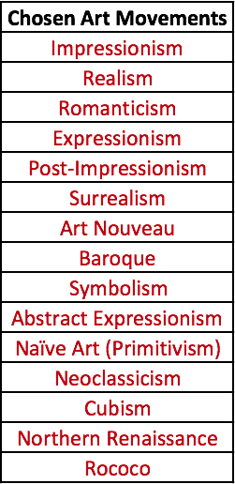

Wikiart dataset based on art movements:

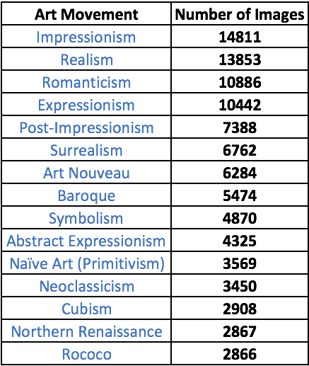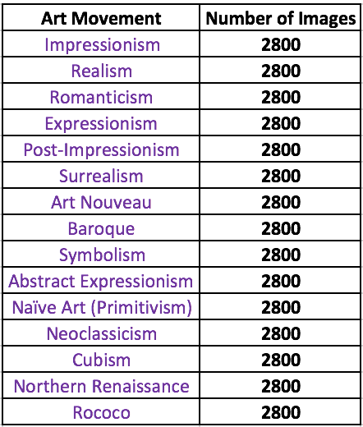



Concrete Description of Approach

1. Downloading images from Wikiart
2. HOG (Histogram of Oriented Gradients) Feature Extraction
3. Elimination of unused art movements
4. Matching art movements with images
5. Deciding on HOG feature size
6. Resizing the images
7. K-Means clustering
8. k-NN Model-building & Preliminary Results
9. Making progress on CNN algorithm

Preliminary Results

Discussion of Challenges and Solutions